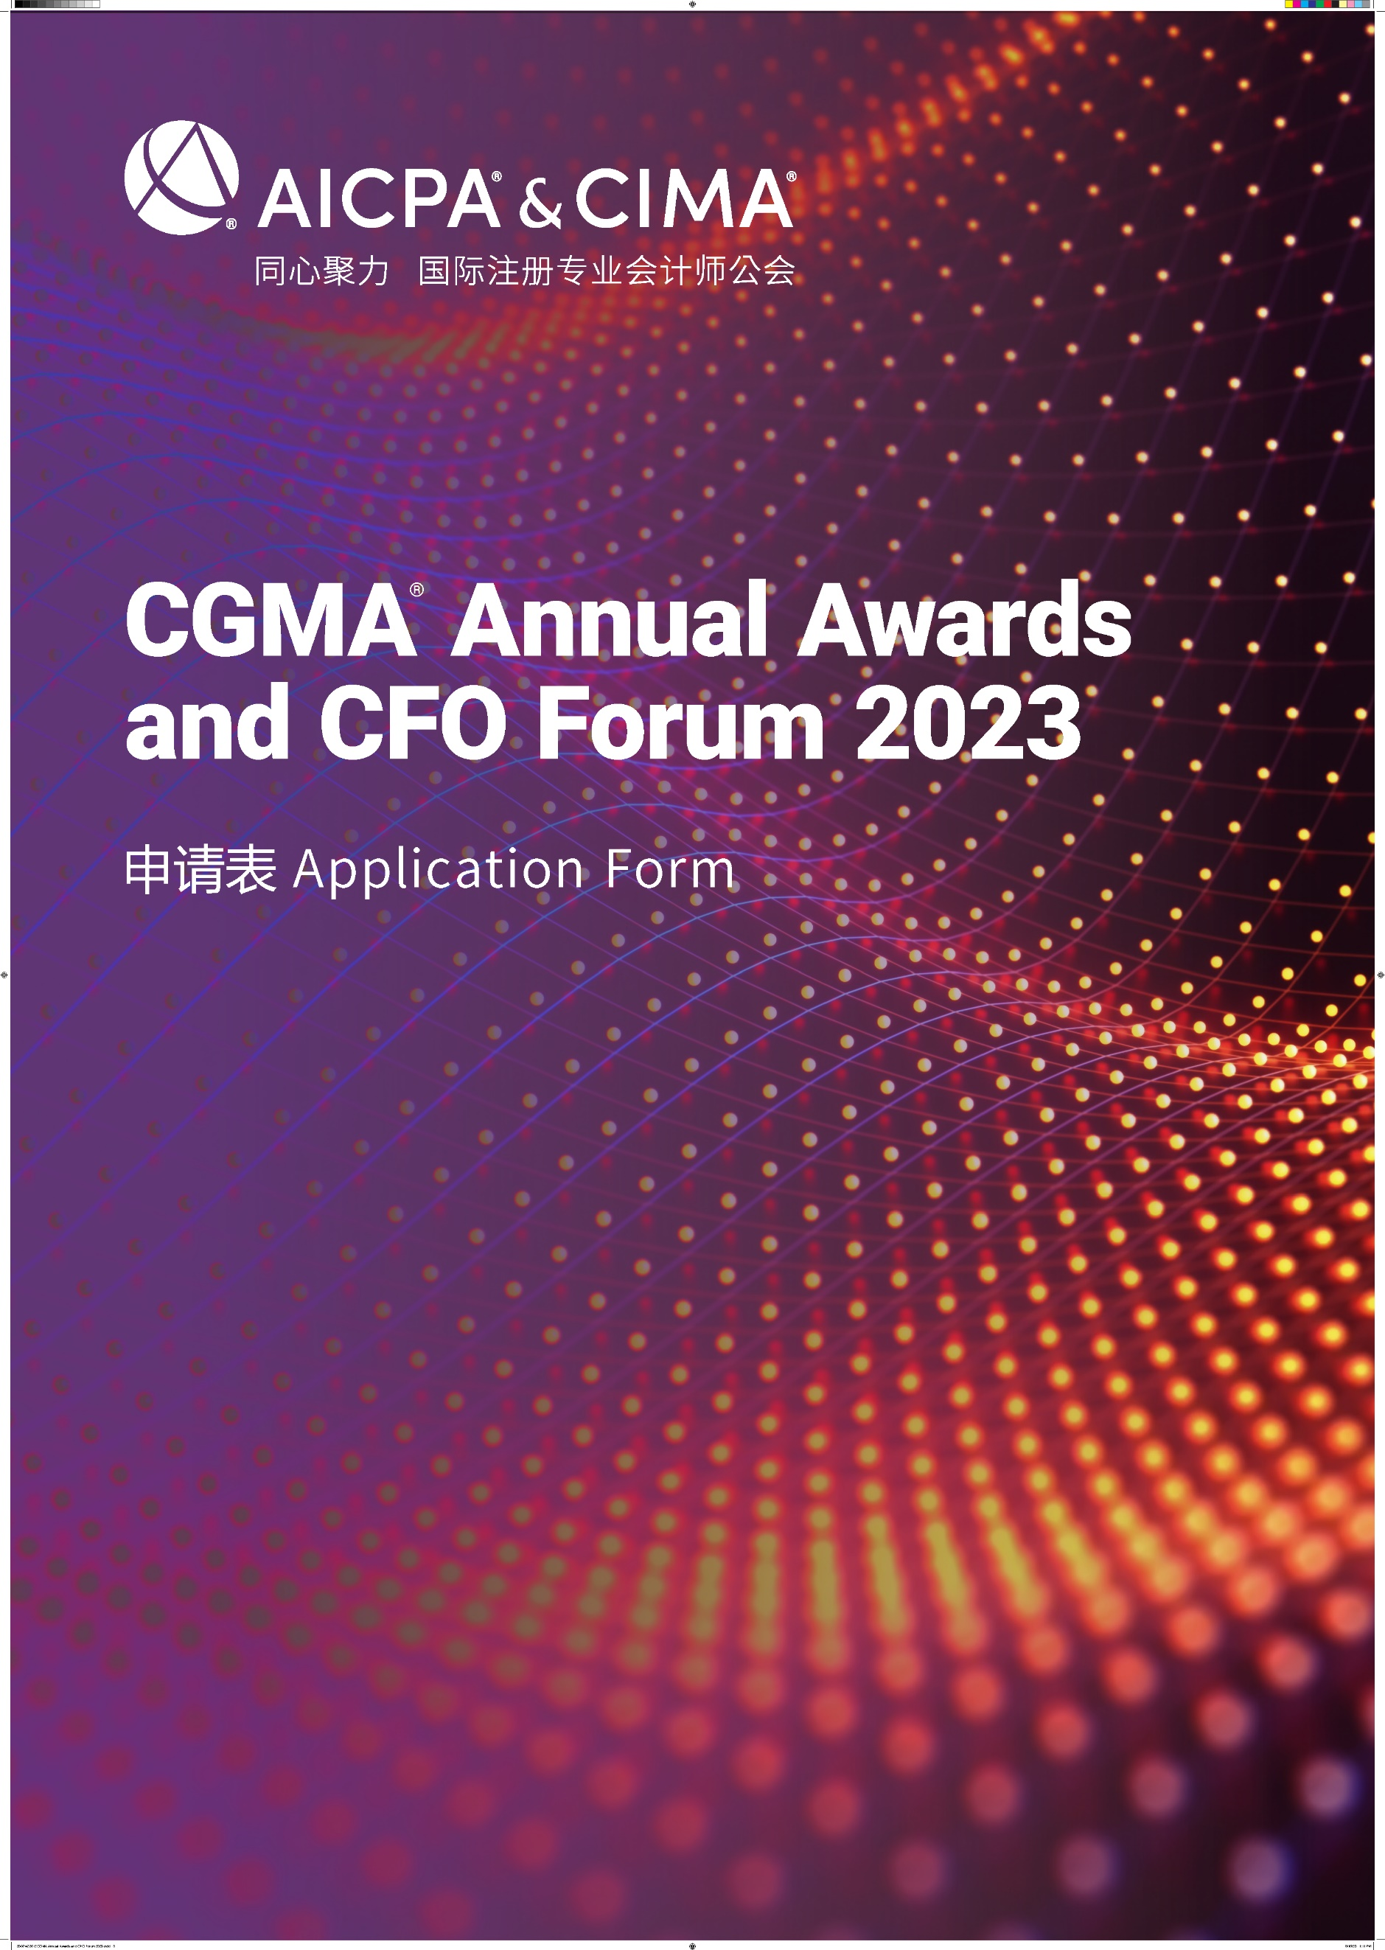

CGMA Most Promising Finance Talent of the Year
This award goes to the CGMA/DMA candidate and ACMA/FCMA/CGMA who demonstrates the greatest potential to be a finance leader in the future. It aims to commend the selected candidates for their relentless learning spirit and the diligence in the development of the management accounting profession. Meanwhile provides a positive boost to the business and value growth of the organization.
年度财界新锐
本奖项授予有突出潜力成为未来财界领袖的CGMA/DMA学员与持证人。该奖项旨在表彰该入选者对持续深造学习以及对管理会计专业发展的孜孜不倦，并能为所在企业的业务和价值增长提供积极的推动作用。

The award is open to CGMA/DMA candidate and ACMA/FCMA/CGMA under forty-five years old. The candidate shall have been in the same management role for at least one year.
参评人需未满 45周岁，并且在目前的管理职位上任职超过一年。
The student must be nominated by his/her employer. The judges will be looking for:
参评人必须获得他 / 她的雇主的提名。评审团将从以下方面考察各参评人：
•Evidence of potential for corporate leadership. For example, this could be involvement in a project or other initiative, showing how the student achieved the objectives and overcame any obstacles.
•Evidence of strong commitment to continuous learning and professional development;
•Evidence of strong personal characteristics such as confidence and initiative;
•Outcomes and testimonials from key stakeholders.
•表现出企业领导力潜质，例如他 / 她在发起或者参与某个项目时是如何克服障碍，是如何达成目标的；
•对持续深造学习和专业发展孜孜不倦；
•表现出很好的个人性格，例如自信、进取；
•业绩以及其他重要利益相关者的认可；

Rules of Entry
参赛规则
1. Each entry must attach one resume in both English and Chinese for judges’reference.
每位参选人必须提交一份中英文简历供评委参考
2. Each entry must be submitted on a fully completed application form in both English and Chinese.
每位参选人必须提交一份完整的中英文申请表
3. The judges' decision will be final and no correspondence will be entered in the judging process.
评委会的决定为最终决定，在评委决定过程前后不得有任何通信联系
4. The application form should be submitted online by uploading at https://awards2023.cncima.com before the closing date of 10:00 (Beijing time) on 28th,Sept, 2023. 申请表请于2023年9月28日上午10点（北京时间）之前通过 https://awards2023.cncima.com 点击“提交申请表单”完成提交。

AICPA & CIMA will not use any contents and materials you provided for commercial purposes, however, it might be cited or referred for internal publicity within our members and candidates to promote the success and achievements of digital management accounting in China.
Please choose from the following communication and publicity options that if you are not willing to share or exposure. (□ media release, □ interviews, □ marketing materials).
AICPA & CIMA (国际注册专业会计师公会) 不会将您提供的任何内容和材料用于商业目的，但可能会在我们的会员和候选人群体中进行宣传，以推广中国数字化管理会计的成功。
请选择你不希望您的信息出现在以下哪类宣传资料中（ □新闻稿 □访谈 □市场推广资料）

Declaration
申明
I hereby certify that the information given in this entry form is correct and that I am willing to provide supporting documentation, if requested, to verify the information provided.
我在此申明所提供的信息都是准确的，如评委会需要，我可以提供相关的文档以供核实。

Name: Position:
姓名 职位
Signed: Date
签字 日期

Application form
申请表
Your name
姓名
Date of Birth
出生年月
Company name
所在企业
Your job title
职位
Phone No.
手机
Email
邮箱
CGMA candidate or CGMA designation holder  CGMA 学员或CGMA 持证人 | 是 yes （CIMA ID : ）  否 no
DMA candidate  DMA学员 | 是 yes  否 no
Company Introduction & Key Performance (400 words in Chinese and the actual number of words in English)
公司简介及部门主要成就（中文400字，英文按实际字数）

Note: Questions should be completed in no more than approximately 400 words in Chinese and the actual number of words in English. Suggested format: Chinese - Microsoft Yahei, English -Arial, font 12, 1.5 line space.
温馨提示：
- 以下回答请控制在中文400 字以内 ，英文按实际字数 (均须以中英文双语回答)
- 建议格式： 中文-微软雅黑 , 英文-Arial ，字号 12，1.5倍行距

- Please provide details of what you consider your most significant achievements in your current job role; or the greatest barrier to success that you have faced and explain how this challenge was overcome.
请详细说明你认为在当前工作中你最大的成绩是什么？或者你曾经面临并且成功克服的最大的障碍是什么？

- Please explain how you effectively communicate the financial and non-financial information with different stakeholders to improve organization’s performance.
请描述在工作中，你是如何通过与利益相关者的有效沟通，利用财务信息和非财务信息提升组织绩效的？

- As a role model, please give some advice of career development to those who have just started or about to start their finance professional career.
请向刚刚步入或者即将步入职场开始财务职业生涯的年轻人分享你的职业发展的成功经验。

- Please summarize how CGMA study has had a positive influence on your career development. Please describe your planning of continuous professional development.
请概述一下 CGMA 学习对于你的职业发展有何积极的影响，并说明你的持续专业发展规划。

