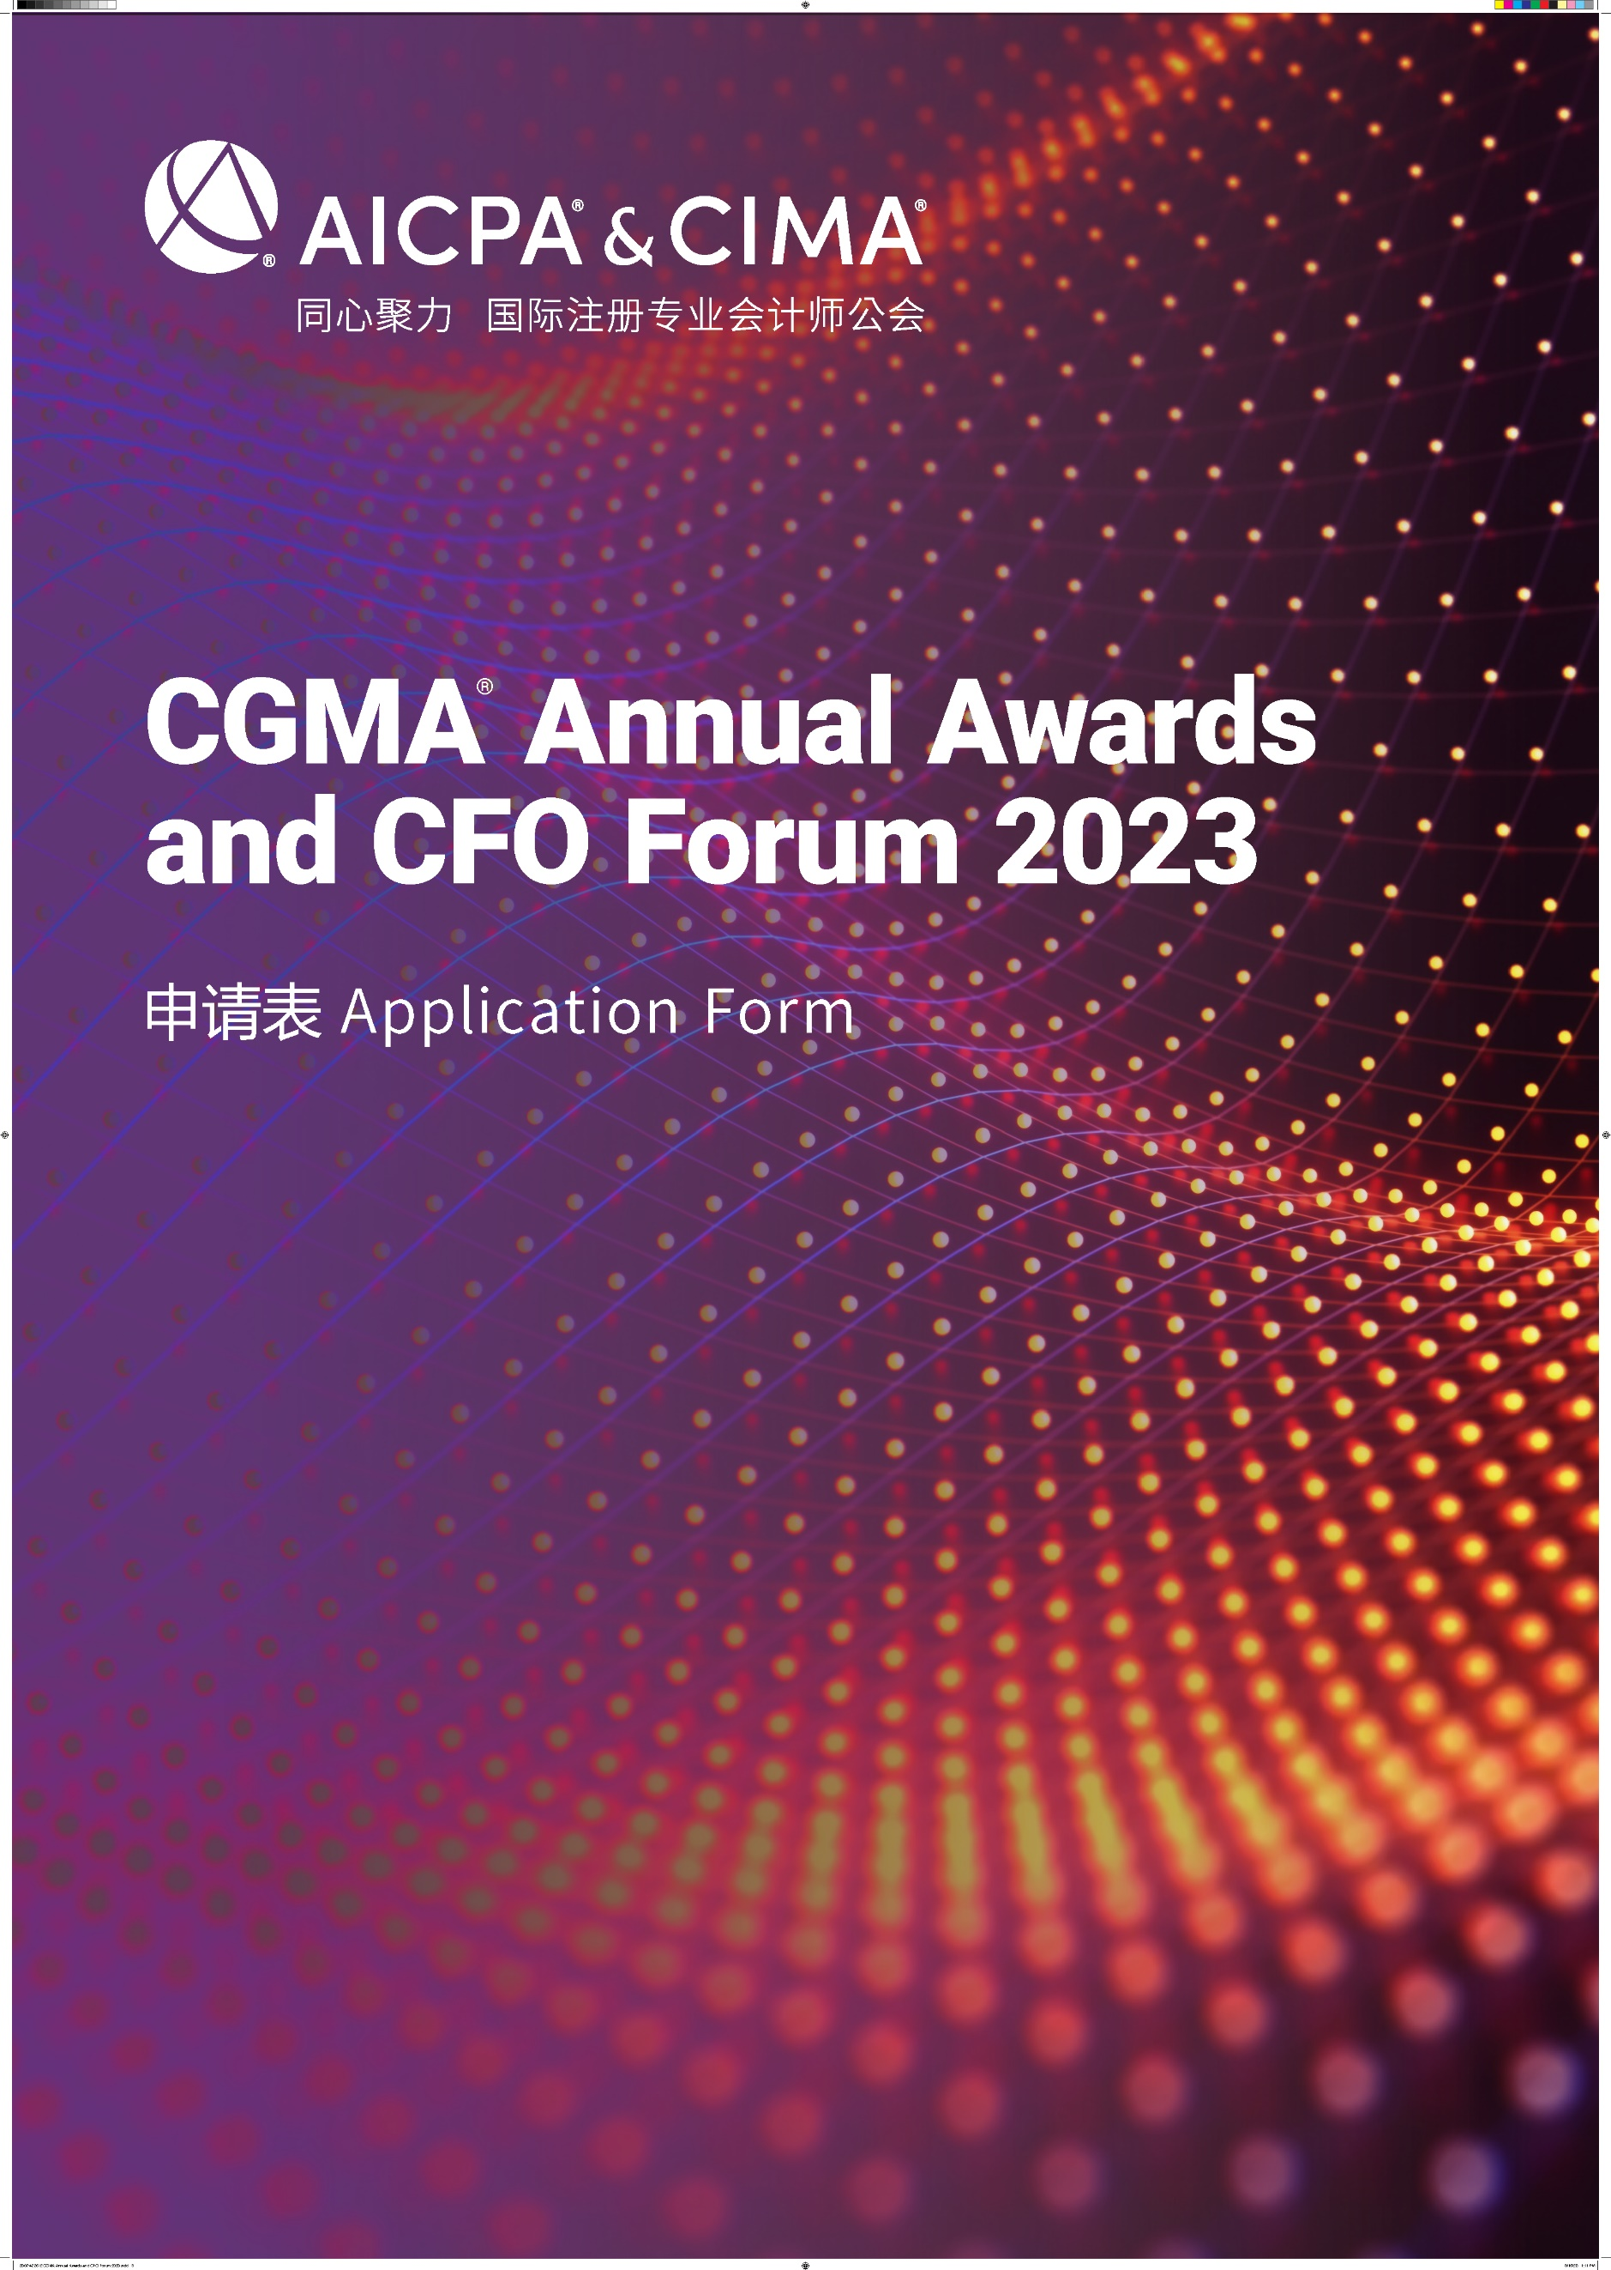

CGMA Best Financial Shared Service Center of the Year
This award recognizes an outstanding shared service center operating in the Chinese market. It celebrates the achievements of a shared service center that has demonstrated the values that the SSC has brought to the organization, successfully drives the construction of the organization’s management accounting system, which in turn contributes to the overall success of the organization foundation continuously optimizes the overall performance level of the organization and has been a key factor of the success of the whole organization.
年度最佳财务共享服务中心
本奖项授予在中国市场运营的卓越共享服务中心，表彰该共享服务中心为整个企业在改善组织职能部门的效率与效用方面带来的价值，不断优化企业的整体绩效水平，进而推动企业管理会计体系的建设，进而为组织的整体成功奠定了基础。
Rules of Entry
参赛规则
1. Each entry can attach one relevant profile for judges’ reference.
每位参选人可提交一份附件供评委参考
2. Each entry must be submitted on a fully completed application form in both English and Chinese.
每位参选人必须提交一份完整的中英文申请表
3. The judges' decision will be final and no correspondence will be entered in the judging process.
评委会的决定为最终决定，在评委决定过程前后不得有任何通信联系
4. The application form should be submitted online by uploading at https://awards2023.cncima.com before the closing date of 10:00 (Beijing time) on 28th Sept, 2023. 申请表请于2023年9月28日上午10点（北京时间）之前通过 https://awards2023.cncima.com 点击“提交申请表单”完成提交。

AICPA & CIMA will not use any contents and materials you provided for commercial purposes, however, it might be cited or referred for internal publicity within our members and candidates to promote the success and achievements of digital management accounting in China.
Please choose from the following communication and publicity options that if you are not willing to share or exposure. (□ media release, □ interviews, □ marketing materials).
AICPA & CIMA (国际注册专业会计师公会) 不会将您提供的任何内容和材料用于商业目的，但可能会在我们的会员和候选人群体中进行宣传，以推广中国数字化管理会计的成功。
请选择你不希望您的信息出现在以下哪类宣传资料中（ □新闻稿 □访谈 □市场推广资料）

Declaration
申明
I hereby certify that the information given in this entry form is correct and that I am willing to provide supporting documentation, if requested, to verify the information provided.
我在此申明所提供的信息都是准确的，如评委会需要，我可以提供相关的文档以供核实。

Name: Position:
姓名 职位
Signed: Date
签字 日期

Application form
申请表
Company name
参评公司
Contact person
联系人姓名
Job title
联系人职位
Phone No.
手机
Email
邮箱
Company Introduction & Key Performance (400 words in English and Chinese respectively)
公司简介及部门主要成就（中文400字，英文按实际字数）

Note: Questions should be completed in no more than approximately 400 words in Chinese and the actual number of words in English. Suggested format: Chinese - Microsoft Yahei, English -Arial, font 12, 1.5 line space.
温馨提示：
- 以下回答请控制在中文400 字以内 ，英文按实际字数 (均须以中英文双语回答)
- 建议格式： 中文-微软雅黑 , 英文-Arial ，字号 12，1.5倍行距

1) Please demonstrate how the SSC has contributed to improve the efficiency and effectiveness of your function department, and how to improve the overall performance of your company?
请说明财务共享服务中心是如何改善了你所在组织整个职能部门的效率与效用？怎样帮助提高了公司的整体绩效水平？

2) Please demonstrate your training scheme to cultivate talents for the SSC and/or for the whole organization.
请说明你们是如何为财务共享服务中心乃至整个企业培养人才的？

3) Please describe how other business units are rating your services? Quotes and endorsement from your customers will be a plus.
请说明其他业务部门是如何评价你们的服务的？（客户的支持与感言将为您的申请加分）。

4）Please demonstrate a best practice case of SSC in your organization.
请列举一个贵企业在财务共享领域的成功案例。

