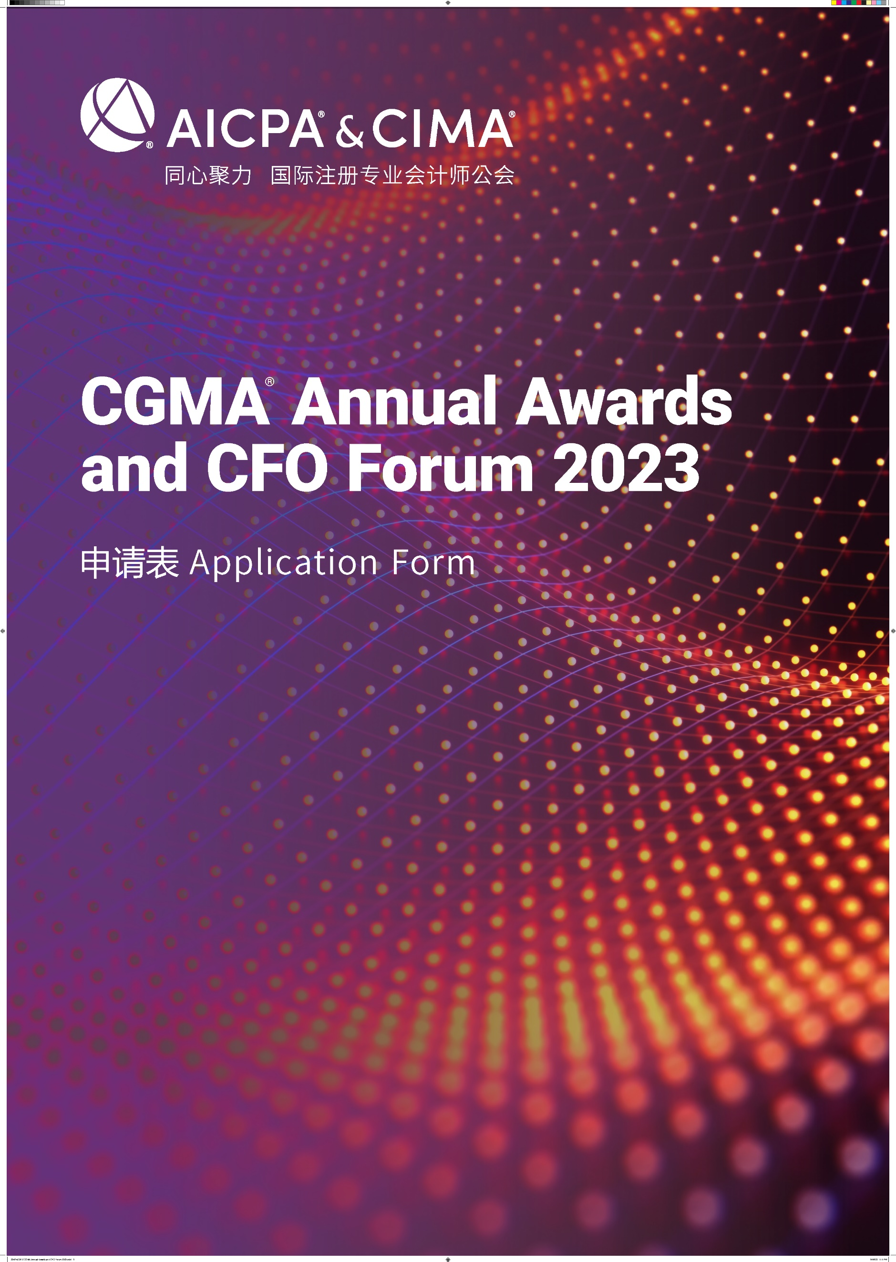

CGMA Best Practice of Management Accounting of the Year
This award recognizes the finance team and celebrates the achievements which demonstrated how well the innovation and practice of management accounting has contributed to the overall success. The team provides influential suggestions and drives to make decisions and implement strategies. It plays a key role in assessing the financial status and risks and maintaining the continuous development of the business. Through digital technology and data analysis, it aims to drive the accomplishment of the organization's overall strategy.
年度最佳管理会计实践
本奖项授予在中国市场运营的企业财务团队，表彰该团队在管理会计的创新与实践方面的优异表现，通过提供有影响力的建议、驱动对战略做出决策和贯彻，并在评估企业财务状况和风险方面发挥着关键作用，同时以数据积累为基础，促进业财融合、优化资源配置，积极推进管理会计实践，推动组织整体战略的达成。

Rules of Entry
参赛规则
1. Each entry can attach one relevant profile for judges’ reference.
每位参选人可提交一份附件供评委参考
2. Each entry must be submitted on a fully completed application form in both English and Chinese.
每位参选人必须提交一份完整的中英文申请表
3. The judges' decision will be final and no correspondence will be entered in the judging process.
评委会的决定为最终决定，在评委决定过程前后不得有任何通信联系
4. The application form should be submitted online by uploading at https://awards2023.cncima.com before the closing date of 10:00 (Beijing time) on 28th Sept, 2023. 申请表请于2023年9月28日上午10点（北京时间）之前通过 https://awards2023.cncima.com 点击“提交申请表单”完成提交。

AICPA & CIMA will not use any contents and materials you provided for commercial purposes, however, it might be cited or referred for internal publicity within our members and candidates to promote the success and achievements of digital management accounting in China.
Please choose from the following communication and publicity options that if you are not willing to share or exposure. (□ media release, □ interviews, □ marketing materials).
AICPA & CIMA (国际注册专业会计师公会) 不会将您提供的任何内容和材料用于商业目的，但可能会在我们的会员和候选人群体中进行宣传，以推广中国数字化管理会计的成功。
请选择你不希望您的信息出现在以下哪类宣传资料中（ □新闻稿 □访谈 □市场推广资料）

Declaration
申明
I hereby certify that the information given in this entry form is correct and that I am willing to provide supporting documentation, if requested, to verify the information provided.
我在此申明所提供的信息都是准确的，如评委会需要，我可以提供相关的文档以供核实。

Name: Position:
姓名 职位
Signed: Date
签字 日期

Application form
申请表
Company name
参评公司
Contact person
联系人姓名
Job title
联系人职位
Phone No.
手机
Email
邮箱
Company Introduction & Key Performance (400 words in Chinese and the actual number of words in English)
公司简介及部门主要成就（中文400字，英文按实际字数）

Note: Questions should be completed in no more than approximately 400 words in Chinese and the actual number of words in English. Suggested format: Chinese - Microsoft Yahei, English -Arial, font 12, 1.5 line space.
温馨提示：
- 以下回答请控制在中文400 字以内 ，英文按实际字数 (均须以中英文双语回答)
- 建议格式： 中文-微软雅黑 , 英文-Arial ，字号 12，1.5倍行距

- Please demonstrate how your team communicating insightful information that is influential to drive better decisions on strategy and its execution at all levels?
请说明你们的团队如何通过沟通有价值的信息，提供有影响力的建议，驱动对战略做出更好的决策，并全方位贯彻?

- Please demonstrate how your team actively manage relationships and resources so that the financial and non-financial assets, reputation and value of the organization are protected?
请说明你们的团队如何积极维护各种关系和资源，使组织的财务和非财务资产、声誉和价值得到保护？

- Please demonstrate if your team simulate different scenarios that demonstrate the cause-and-effect relationships between inputs and outcomes and how did your team analyze information and evaluate opportunities and risks? Please describe how management accounting create values for your organization.
请说明你的团队是否通过模拟不同场景，分析投入和产出之间的因果关系，并分析和评估机会和风险? 请陈述管理会计如何助力你的组织创造价值？

- Please demonstrate a best practice case of management accounting in your organization. To meet the trend of digitalization, please describe your team’s information and digital literacy from the perspective how your team utilize digital technology and data analytics to support overall data strategy and planning.
请举一个你所在组织的管理会计成功案例。应对数字化发展趋势， 请说明你的财务团队是否具有一定的信息和数字素养，你们是如何运用数字技术和数据分析来支持组织的整体数字战略和规划的？

