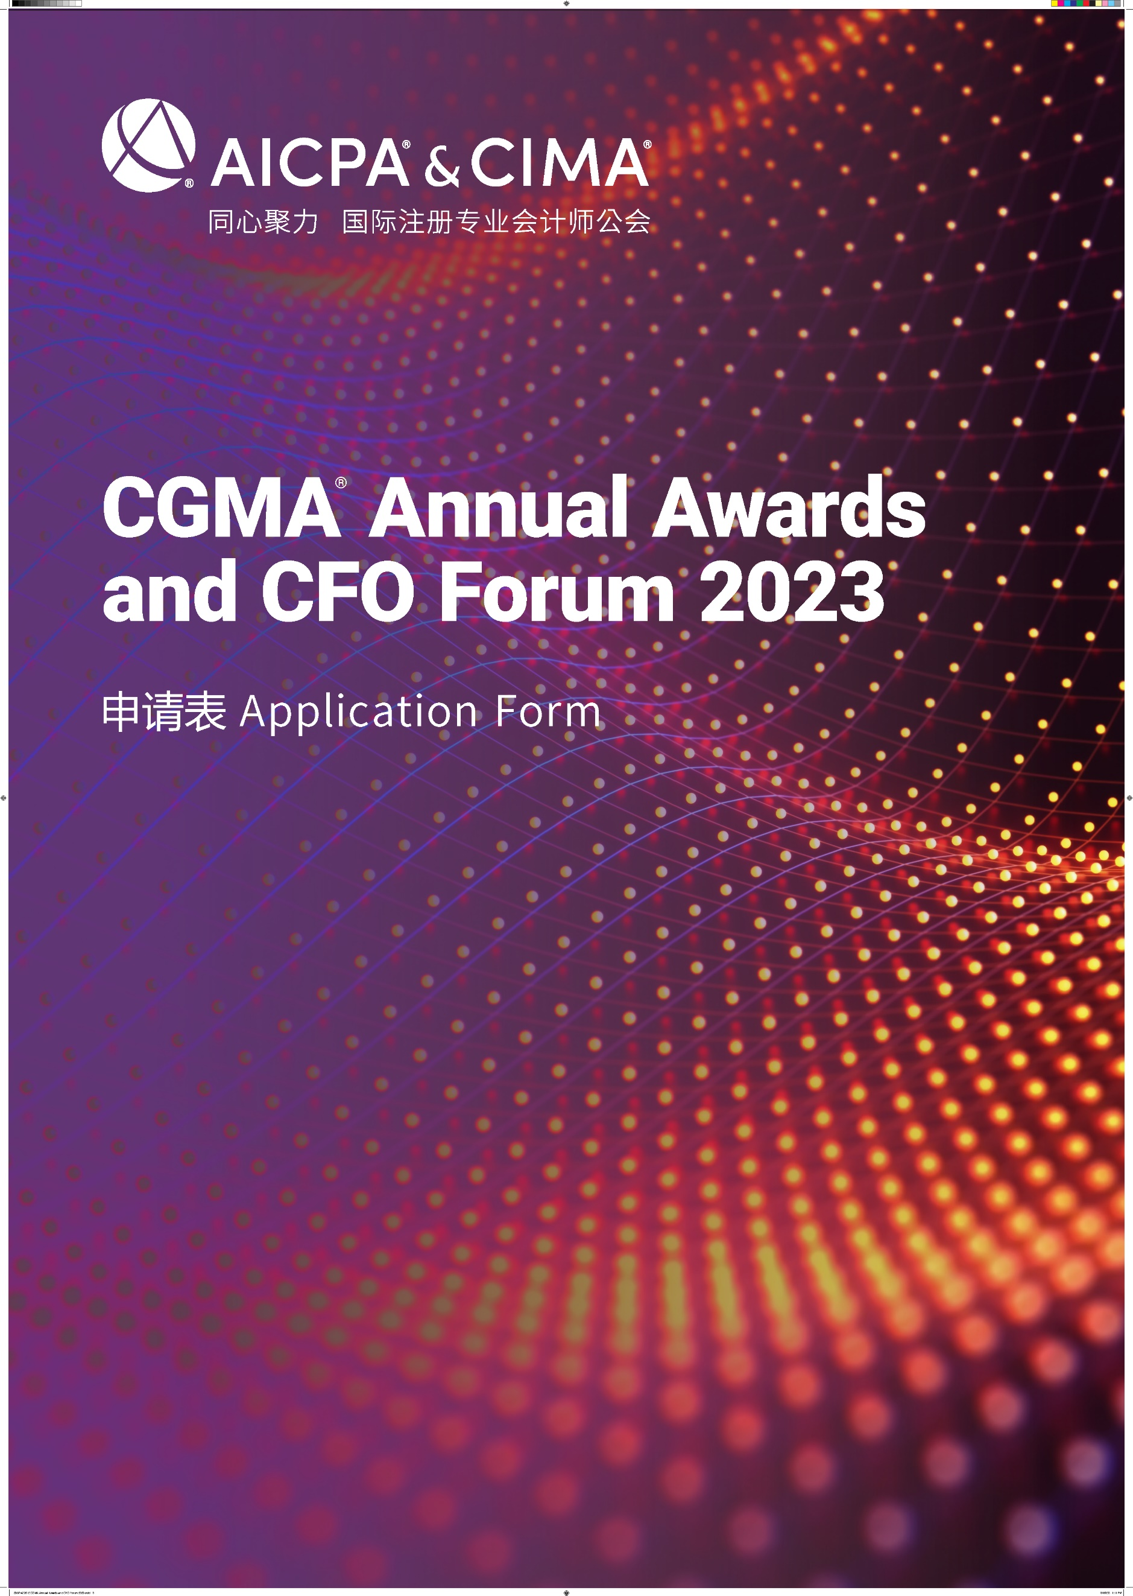

CGMA Best Practice of RPA of the Year
This award recognizes the top RPA initiative in the industry, it celebrates the positive impact and performance improvement brought to the entire organization. Through the RPA project, successfully drives the construction of the organization's management accounting system, which in turn contributes to the overall success of the organization foundation and improve the adaptability in the process of digital transformation.
年度最佳机器人流程自动化（RPA）实践奖项
本奖项授予行业内顶尖的机器人流程自动化项目本奖项授予行业内顶尖的机器人流程自动化项目，表彰具有自动化优先思维的企业，通过该新兴技术项目的部署，为整个企业带来的积极影响和绩效的提升实现企业数字化转型过程中灵活应变。
参赛规则
1. Each entry can attach one relevant profile for judges’ reference.
每位参选人可提交一份附件供评委参考
2. Each entry must be submitted on a fully completed application form in both English and Chinese.
每位参选人必须提交一份完整的中英文申请表
3. The judges' decision will be final and no correspondence will be entered in the judging process.
评委会的决定为最终决定，在评委决定过程前后不得有任何通信联系
4. The application form should be submitted online by uploading at https://awards2023.cncima.com before the closing date of 10:00 (Beijing time) on 28th Sept, 2023. 申请表请于2023年9月28日上午10点（北京时间）之前通过 https://awards2023.cncima.com 点击“提交申请表单”完成提交。

AICPA & CIMA will not use any contents and materials you provided for commercial purposes, however, it might be cited or referred for internal publicity within our members and candidates to promote the success and achievements of digital management accounting in China.
Please choose from the following communication and publicity options that if you are not willing to share or exposure. (□ media release, □ interviews, □ marketing materials).
AICPA & CIMA (国际注册专业会计师公会) 不会将您提供的任何内容和材料用于商业目的，但可能会在我们的会员和候选人群体中进行宣传，以推广中国数字化管理会计的成功。
请选择你不希望您的信息出现在以下哪类宣传资料中（ □新闻稿 □访谈 □市场推广资料）

Declaration
申明
I hereby certify that the information given in this entry form is correct and that I am willing to provide supporting documentation, if requested, to verify the information provided.
我在此申明所提供的信息都是准确的，如评委会需要，我可以提供相关的文档以供核实。

Name: Position:
姓名 职位
Signed: Date
签字 日期

Application form
申请表
Company name
参评公司
Contact person
联系人姓名
Job title
联系人职位
Phone No.
手机
Email
邮箱
Company Introduction & Key Performance (400 words in Chinese and the actual number of words in English)
公司简介及部门主要成就（中文400字，英文按实际字数）

Note: Questions should be completed in no more than approximately 400 words in Chinese and the actual number of words in English. Suggested format: Chinese - Microsoft Yahei, English -Arial, font 12, 1.5 line space.
温馨提示：
- 以下回答请控制在中文400 字以内 ，英文按实际字数 (均须以中英文双语回答)
- 建议格式： 中文-微软雅黑 , 英文-Arial ，字号 12，1.5倍行距

1) Please demonstrate how the RPA initiative is strategically positioned in the digital strategy of your organization.
请说明贵公司机器人流程自动化（RPA）项目在企业的数字化战略中是如何定位的？

2) Please describe how RPA initiative has been implemented in your organization. What impacts the implementation of new technology RPA had on your company, or in what ways has the RPA improved the overall performance of your company?
请说明机器人流程自动化项目是如何在你的公司中部署和实施的，相关的运用对于贵公司产生了哪些影响？怎样帮助提高了公司的整体绩效水平？

3）How your organization supports the construction of management accounting system through RPA initiative?
请说明贵公司是如何通过机器人流程自动化项目支撑企业管理会计体系建设的。

4) Please describe the next step of the overall digital strategy of your organization based on current RPA strategy.
基于目前实施的机器人流程自动化战略，请分享贵公司数字化人才部署和人才培养计划以及下一步的整体数字化战略。

