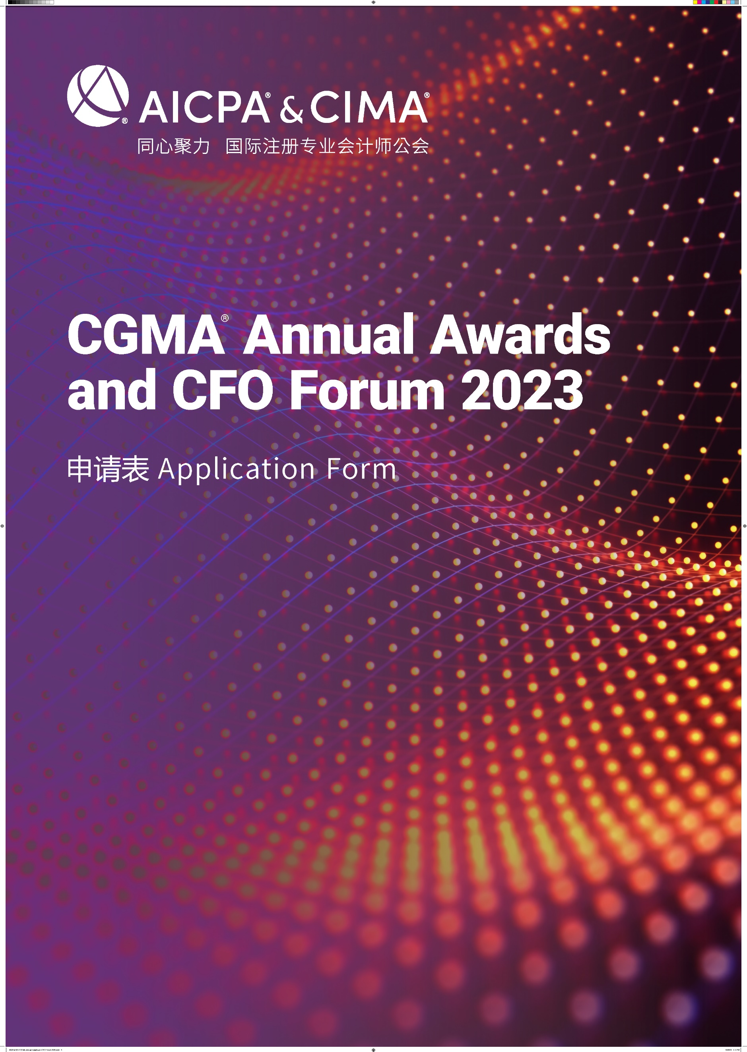

CGMA Best Innovation of Digital Management Accounting of the Year
This award recognizes enterprises that have made innovative contributions in the digital transformation. They are excellent representatives of the development of digital management accounting, and they provide great reference for the Chinese enterprises that in the process of upgrading and evolution of digital management accounting. They have been deeply engaged in the field of digital management accounting for many years. More importantly, they have empowered their financial teams with digital and intelligent tools, reshaped management accounting system and multi-business scenario financial decision support through innovative methods and supported the digital transformation with financial transformation driven business excellence.
年度最佳数字化管理会计创新
本奖项授予在数字化转型中做出创新贡献的企业，他们是数字化管理会计发展的优秀代表，为中国企业数字化管理会计的升级发展提供借鉴。他们多年深耕数字化管理会计领域，以数字化、智能化工具赋能企业，通过创新方式重塑管理会计体系和多业务场景财务决策支持，以财务变革驱动业务的卓越运营支持企业数字化转型。

Rules of Entry
参赛规则
1. Each entry can attach one relevant profile for judges’ reference.
每位参选人可提交一份附件供评委参考
2. Each entry must be submitted on a fully completed application form in both English and Chinese.
每位参选人必须提交一份完整的中英文申请表
3. The judges' decision will be final and no correspondence will be entered in the judging process.
评委会的决定为最终决定，在评委决定过程前后不得有任何通信联系
4. The application form should be submitted online by uploading at https://awards2023.cncima.com before the closing date of 10:00 (Beijing time) on 28th Sept, 2023. 申请表请于2023年9月28日上午10点（北京时间）之前通过 https://awards2023.cncima.com 点击“提交申请表单”完成提交。

AICPA & CIMA will not use any contents and materials you provided for commercial purposes, however, it might be cited or referred for internal publicity within our members and candidates to promote the success and achievements of digital management accounting in China.
Please choose from the following communication and publicity options that if you are not willing to share or exposure. (□ media release, □ interviews, □ marketing materials).
AICPA & CIMA (国际注册专业会计师公会) 不会将您提供的任何内容和材料用于商业目的，但可能会在我们的会员和候选人群体中进行宣传，以推广中国数字化管理会计的成功。
请选择你不希望您的信息出现在以下哪类宣传资料中（ □新闻稿 □访谈 □市场推广资料）

Declaration
申明
I hereby certify that the information given in this entry form is correct and that I am willing to provide supporting documentation, if requested, to verify the information provided.
我在此申明所提供的信息都是准确的，如评委会需要，我可以提供相关的文档以供核实。

Name: Position:
姓名 职位
Signed: Date
签字 日期

Application form
申请表
Company name
参评公司
Contact person
联系人姓名
Job title
联系人职位
Phone No.
手机
Email
邮箱
Company Introduction & Key Performance (400 words in Chinese and the actual number of words in English)
公司简介及部门主要成就（中文400字，英文按实际字数）

Note: Questions should be completed in no more than approximately 400 words in Chinese and the actual number of words in English. Suggested format: Chinese - Microsoft Yahei, English -Arial, font 12, 1.5 line space.
温馨提示：
- 以下回答请控制在中文400 字以内 ，英文按实际字数 (均须以中英文双语回答)
- 建议格式： 中文-微软雅黑 , 英文-Arial ，字号 12，1.5倍行距

- Please demonstrate your company’s digital transformation process and the landmark progress and how does digital management accounting help your company create value.
请说明贵企业的数字化转型进程及标志性进展，以及数字化管理会计如何助力贵企业创造价值。

- Please provide a best practice case of an innovation your company has made in the process of financial digital transformation?
请列举一个贵企业在财务数字化转型进程中所做出的创新案例。

- Please demonstrate how your finance team uses digital approaches and methods to support your company’s digital transformation strategy.
请说明你们的财务团队是如何运用数字化工具和方法来支持企业的整体数字化转型战略。

- Please briefly state how your financial team has responded to the digital transformation by upgrading their talent skills.
请简要说明贵企业在财务数字化转型中，财务团队是如何通过提升人才技能来应对转型。

